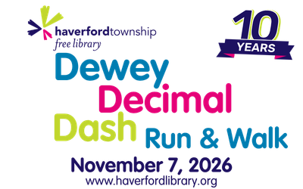
Haverford Township Free Library - 2026
Business Sponsorship Packages – Dewey Decimal Dash Run and Walk
For inclusion on the t-shirt, please respond by Friday, October 23, 2026
 |  | Event Naming Rights | Present Top Awards | Meet and Greet Table at Event | Social Media Feature | Race Registrations | Logo on  T-shirt | Feature on Library rotating Digital Display | Name & logo on Library website and Connection newsletter for 1 year
Platinum | $2,500 |  |  |  | 2 individual posts throughout the year, thanking you for your support | 4 | Top placement | Featured name and logo
Gold | $1,000 |  |  |  | 1 individual post throughout the year, thanking you for your support | 2 | Premier placement | Name and logo
Silver | $500 |  |  |  | 2 group posts throughout the year, thanking you for your support | 1 |  | logo
Bronze | $250 |  |  |  | 1 group post throughout the year, thanking you for your support |  |  | Name

Business Sponsor Information
Company Name:____________________________________
Contact Name: _____________________________________
Address: _________________________________________
City: ________________ State: ______ Zip: ______________
Phone Number: _____________________________________
Email: ___________________________________________
Dewey Decimal Dash Run and Walk Sponsor Level: ____________
- Check is enclosed (Please make checks payable to Haverford Township Free Library Assn)
- For credit card donations, go to www.haverfordlibrary.org/donate to make a payment

Please mail this form, along with your contribution to:
Haverford Township Free Library Assn
1601 Darby Rd.
Havertown, PA 19083
Contact Maggie Esteves at 610-446-3082 x 514 or esteves@haverfordlibrary.org with questions or for more information.

